**DAILY ONLINE ACTIVITIES SUMMARY**

|  |  |  |  |  |  |  |  |  |
| --- | --- | --- | --- | --- | --- | --- | --- | --- |
| **Date:** | **01/06/2020** | | | | | **Name:** | **Rahul J** | |
| **Sem & Sec** | **8th sem B sec** | | | | | **USN:** | **4AL16CS130** | |
| **Online Test Summary** | | | | | | | | |
| **Subject** | | **SMS** | | | | | | |
| **Max. Marks** | | **60** | | **Score** | | | **60** | |
| **Certification Course Summary** | | | | | | | | |
| **Course** | **Cloud foundations** | | | | | | | |
| **Certificate Provider** | | | **Great learning** | | **Duration** | | | **4.5 Hours** |
| **Coding Challenges** | | | | | | | | |
| **Problem Statement:**  **Python program for palimdrome** | | | | | | | | |
| **Status: Solved** | | | | | | | | |
| **Uploaded the report in Github** | | | | | **Uploaded** | | | |
| **If yes Repository name** | | | | | **Rahul_j** | | | |
| **Uploaded the report in slack** | | | | | **Yes** | | | |

Online Test Details:

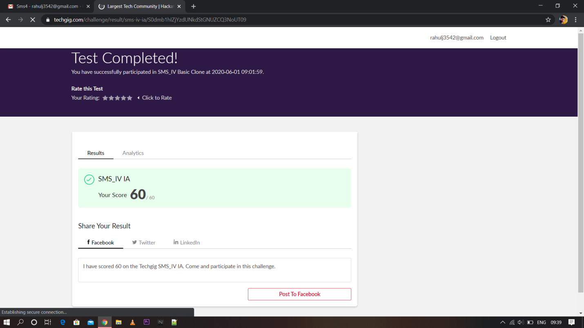

Certification Course Details:

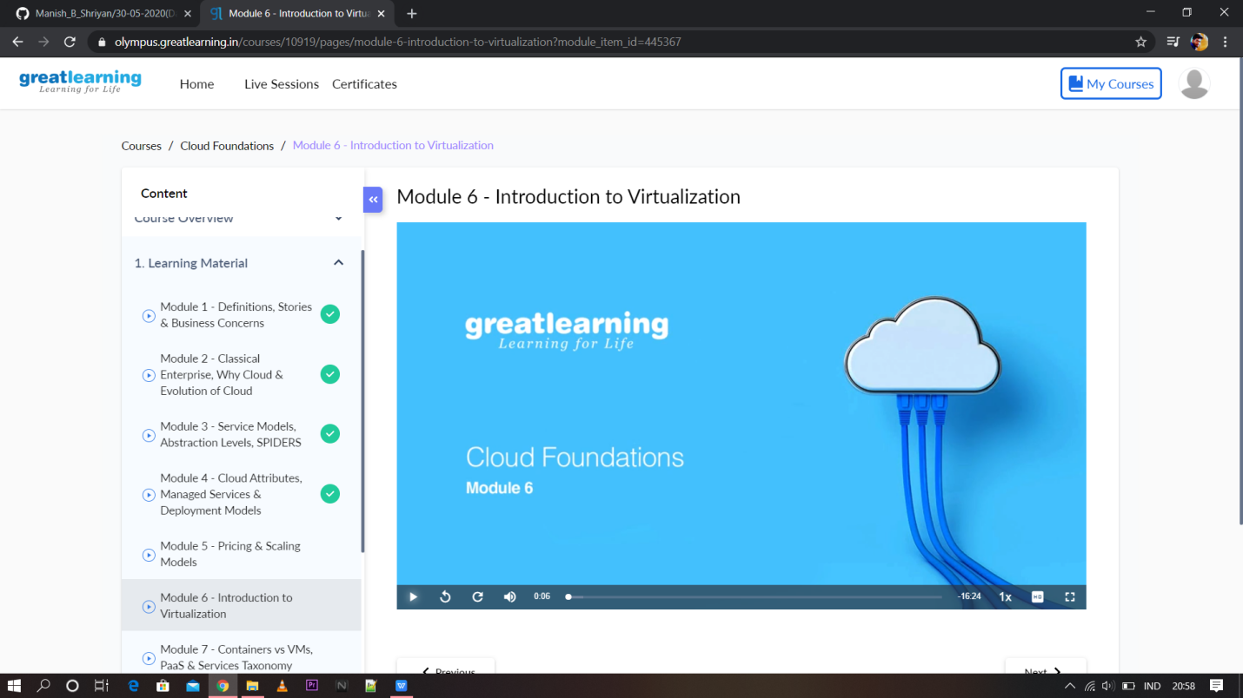

Coding Challenges Details:

|  |
| --- |
|  |
|  |  |
|  |  |
|  |  |
|  |  |
|  |  |
|  |  |
|  |  |
|  |  |
|  |  |
|  |  |

|  |
| --- |
| n=int(input("Enter number:")) |
|  | temp=n |
|  | rev=0 |
|  | while(n>0): |
|  | dig=n%10 |
|  | rev=rev*10+dig |
|  | n=n//10 |
|  | if(temp==rev): |
|  | print("The number is a palindrome!") |
|  | else: |
|  | print("The number isn't a palindrome!") |